
St Peter’s Centre, 3rd floor, Church Street,
Burnley, Lancashire. BB11 2DL
Manchester Road Surgery, 187-189 Manchester Road,
Burnley, Lancashire. BB11 4HP
Kiddrow Lane Health Centre, Kiddrow Lane,
Burnley, Lancashire. BB12 6LH


Burnley Group Practice
This Photo by Unknown Author is licensed under CC BY
PATIENT NEWSLETTER AUGUST 2026
FRIENDS & FAMILY We regularly ask you for your opinion, letting us know what you think of our service, and suggestions of any improvements we can make to maintain a high level of service. We received 318 responses in June 2026 and 85.5% of patients rated their experience as either Good or Very Good, demonstrating a high level of overall satisfaction. The purpose of this is to get feedback on what the practice is doing well, and what processes may need improvement, and the Friends and Family test allows you to do this anonymously.

OPENING TIMES
Monday 08:00am -18:30pm
Tuesday 08:00am -18:30pm
Wednesday 08:00am -18:30pm
Thursday 08:00am -18:30pm
Friday 08:00am -18:30pm
CONTACT DETAILS
Tel: 01282 911630
Email: burnley.gp@nhs.net
WHEN WE ARE CLOSED there is always an out of hours doctor available. Should you require an out of hours appointment you should call 111.
Call 999 in an emergency. Chest pains and/or shortness of breath constitute to an emergency

PATIENT PARTICIPATION GROUP
A Patient Participation Group (PPG) consists of a group of patients who come forward to attend regular meetings, to make suggestions and help make the service work as well as it can for patients, clinicians and other staff members.
Your experience matters and you can bring different ideas to the surgery to help us treat patients better or to improve what we do in some way. You will gain a better understanding of the NHS, and this allows us to gather feedback from other patients. The group gives you the opportunity to raise awareness on how we can support you and the community.
Our PPG group has the intention of setting goals and agendas based on what the group thinks important, using it as a platform to share important information and members of the PPG will take part in friendly open discussions.
If you would like to attend meetings, or would like more information, please get in touch by emailing burnley.gp@nhs.net for the attention of Brenda - Practice Secretary.



ORDERING MEDICATION VIA THE NHS APP OR THE ACCURX LINK
From the 1st of June we stopped accepting prescription requests via email. You can order your medication via the NHS app or through the AccuRx link - these are the safest ways to order your medications.
NHS app - Open the app click Prescriptions, then request a repeat prescription, this will then check your chosen pharmacy is correct if this is not you can also change your nominated pharmacy on the app, this will then bring up your repeat or variable use prescriptions which you can order. If for some reason some of your medication is on acute you can request this via the box at the bottom of the page if you are requesting a repeat item or via the AccuRx link below.
AccuRx - to order via AccuRx click the link, then click I have an admin or routine care request, then go to repeat prescription, add in your details and the medication you require and submit. This then comes to the surgery and will be saved on your record, then your medication will be ordered by one of the team.
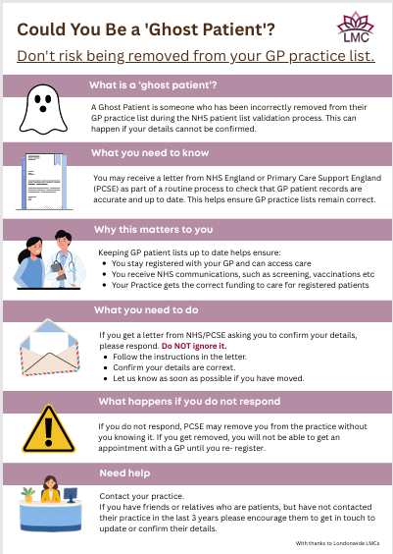
If you have regular medication that you get each month, that you have been on a while (over 3 months), these can be added to repeat dispensing - by doing it this way you no longer have to request your medication each month. How does it work? We send 6 months’ worth of medication to your nominated pharmacy, and this will then drop down at the pharmacy each month, so that you can either collect or have delivered (if they provide this service). Patients over the age of 75 or housebound are still able to order via the telephone.
INTRODUCING OUR NEW MEDICINES MANAGEMENT TEAM The practice has formed a new Medicines Management Team who are a dedicated team that will now be responsible for handling all medication-related work within the practice. The aim of this new team is to ensure that medication requests are processed safely, efficiently, and consistently, while providing patients with a dedicated point of contact for medicines-related support. The team consists of pharmacists, pharmacy technicians and medicines co-ordinators.
What Will the Medicines Management Team Do? The team will be responsible for a range of medication-related tasks, including:
· Processing repeat prescription requests
· Answering questions about medications
· Managing medication related reviews, including monitoring call and recall.
· Liaising with GPs, nurses, pharmacies, and other healthcare professionals regarding medicines
· Supporting patients with prescription queries
Our New Medicines Co-ordinators As part of the development of the team, we are delighted to announce the appointment of our new Medicines Co-ordinators, Jade and Jake.
Jade and Jake originated from our reception team and already have a wealth of knowledge about the practice and our patients. They have undertaken additional training and will work closely with our clinical team to support the safe and effective management of prescriptions and medication requests and will be involved in co-ordinating work around medication monitoring.
Our prescription line is open between 9am and 12 noon Monday to Friday, for eligible patients to order their prescriptions and for patients to contact the practice with medication related queries.

